Dreamgrid Service
All of Outworldz DreamGrid can run as a service. Services start on Power up. This solves many problems with power loss, Updates, and crashes.
You should only enable the DreamGrid Service when DreamGrid is not running.
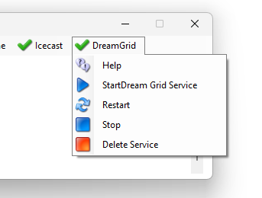
The service receives commands such as stop/start/restart from the same code you are currently running as a GUI. You do not need to run the DreamGrid GUI after starting the Service. You can use this GUI to control the background service.
If you save a setting in the foreground GUI, the service instantly reloads the settings file.

Disabling the Service
You must remove the service to disable it. Use the Service menu at the top of the main DreamGrid window, which has Start DreamGrid Service, Restart, Stop, Delete Service, and Console.
Once the service is deleted, the essential foreground things are re-enabled, and when you click [Start], DreamGrid will boot the foreground DOS boxes, as usual.

Technical Ifo
The service is just DreamGrid's Start.exe with a command line parameter. It starts as a service, boots the grid, reboots on any crash, restart or update, and waits for the regions to close when stopping. We should be safe from Windows updates, at last! No need to remain logged in, either.
You can manually control a service with the command Services.msc. You will see this window:
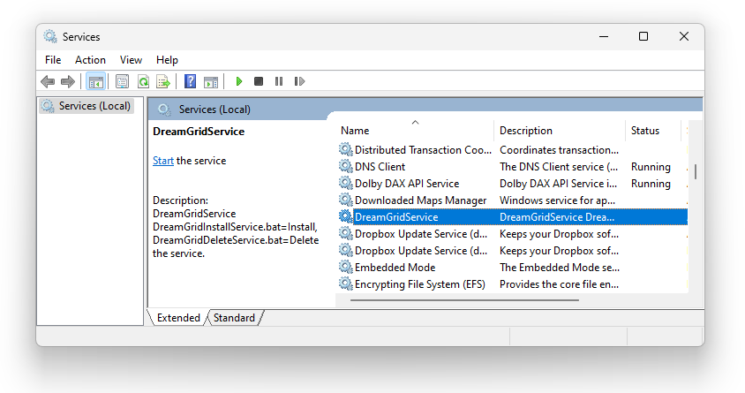
Double clicking the DreamGrid Service will open up a control panel where you can start, stop, enable or disable the Service.
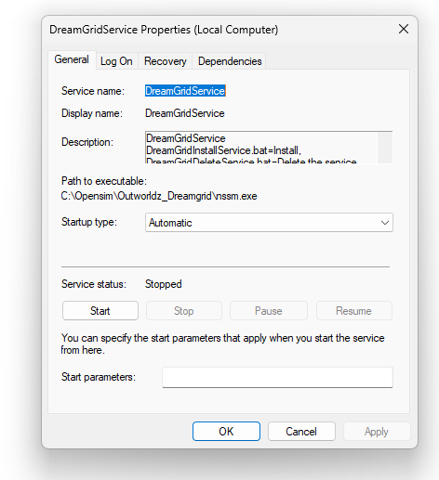

Manual operation
There are batch files that will remove a service or install it.
Use the Service menu's Start DreamGrid Service item to install and start the service.
DreamGridDeleteService.bat will Delete the service.

